Data in SOLR:

Output data is pushed to SOLR using the Shell script command and below are the snapshots of the SOLR data which are retrieved after querying.

Corresponding JSON files are:

Classifier 1: Refrigerator <http://localhost:8983/solr/collection2_shard1_replica1/select?q=id%3A%22Refrigerator%22&wt=json&indent=true>

Classifier 2: Television <http://localhost:8983/solr/collection2_shard1_replica1/select?q=id%3A%22Television%22&wt=json&indent=true>

Classifier 3: Laptop <http://localhost:8983/solr/collection2_shard1_replica1/select?q=id%3A%22Laptop%22&wt=json&indent=true>

When queried with the classifier, all the item numbers under the classifier are retrieved.

Television:

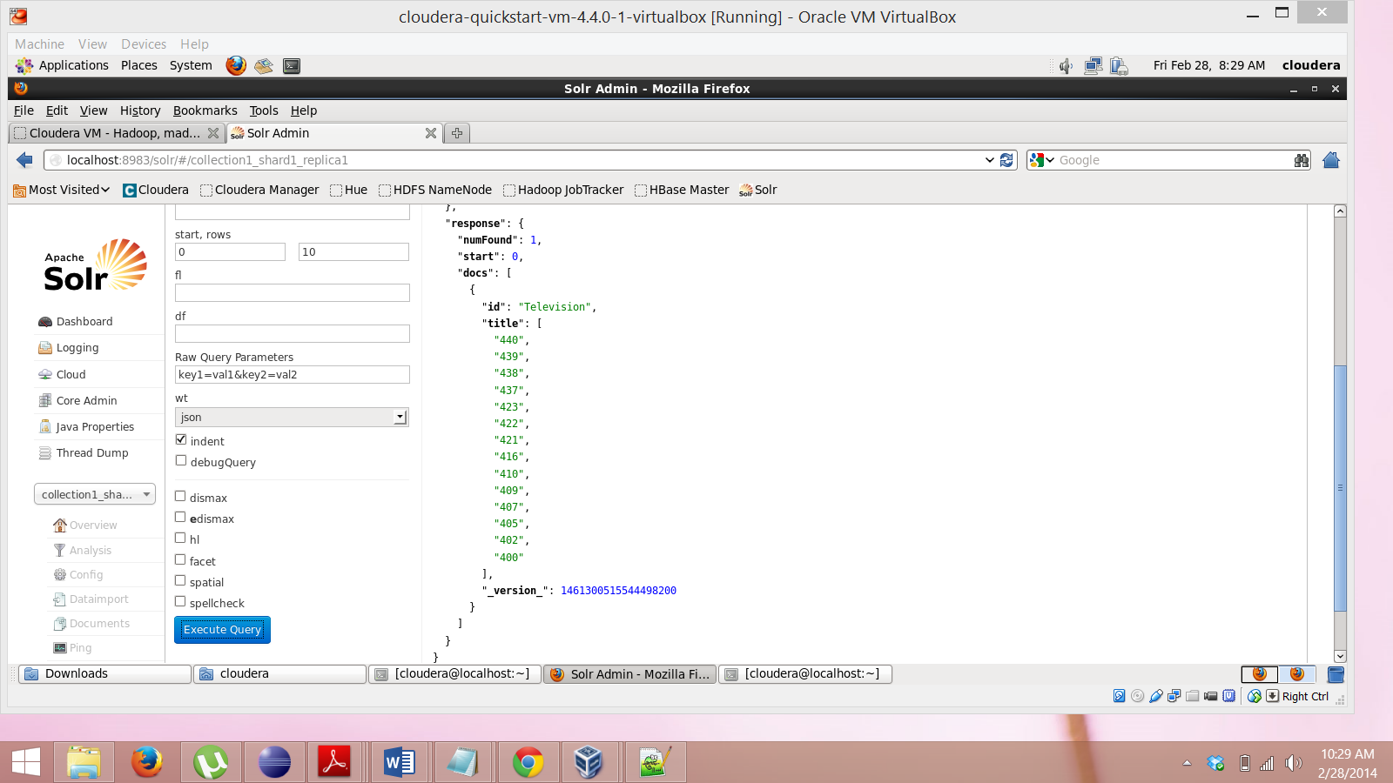

Laptop:

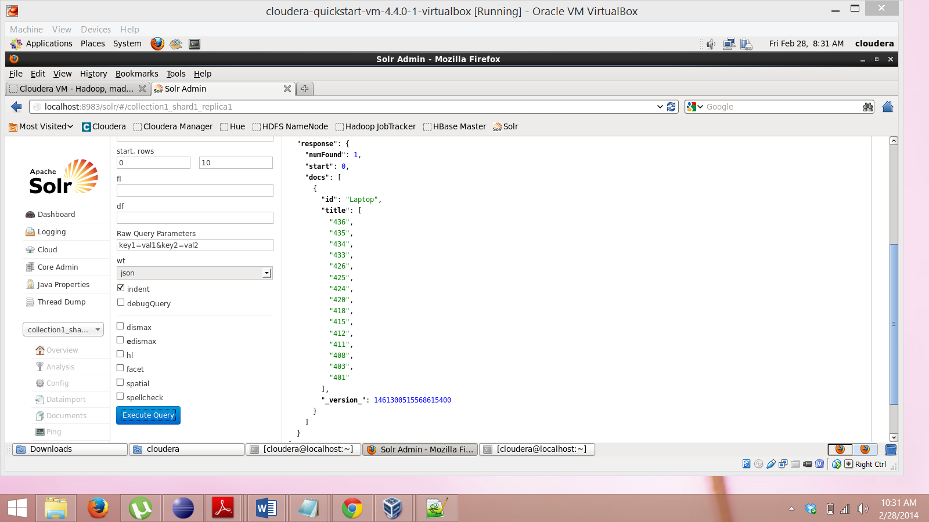

Refrigerator:

